SIMATS ENGINEERING
ASSESSMENT TOOL 1
COURSE CODE: CSA14 COURSE NAME: Compiler Design
COURSE OUTCOME COVERED
CO4: Examine intermediate code generation techniques to enhance code optimization (BL4)
Assessment Tool Weightage: 40%
QUESTIONS: 4 Total Marks:40
Annexure A CLASS TEST
Q.
No
Understanding
of Concepts (25)
Explanation
(25)
Applicatio
n (20)
Organizatio
n(15)
Accuracy(10)
Total
Score
(
out of
100)
1
/ 4
/ 4
/ 4
/ 4
/ 4
2
/ 4
/ 4
/ 4
/ 4
/ 4
3
/ 4
/ 4
/ 4
/ 4
/ 4
4
/ 4
/ 4
/ 4
/ 4
/ 4
5
/ 4
/ 4
/ 4
/ 4
/ 4
OVER
A
LL RUBRI
CS VALUE
/ 4
/ 4
/ 4
/ 4
/ 4
/ 25
/ 30
/ 20
/ 15
/ 10
/ 100
Code of Conduct:
I V.Aravind Chowdary/192321119 (Name / Reg No) certify that this submission is my original work and that I have adhered to the guidelines specified for this assessment.
I understand that any violation of academic integrity rules will result in disciplinary action.
Signature of the student:V.Aravind
Annexure A

CLASS TEST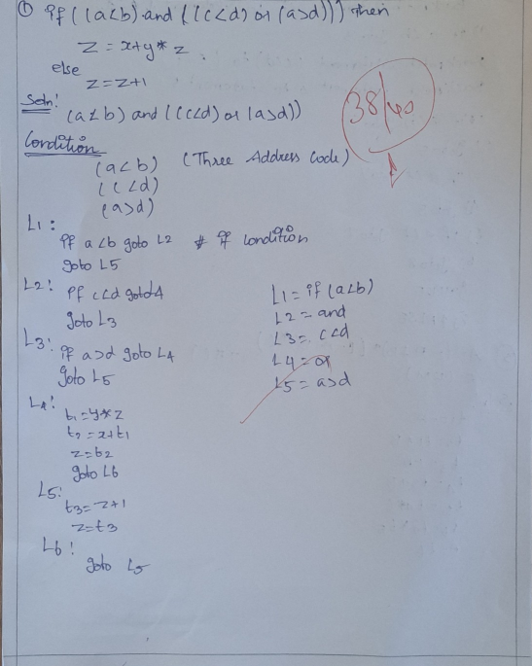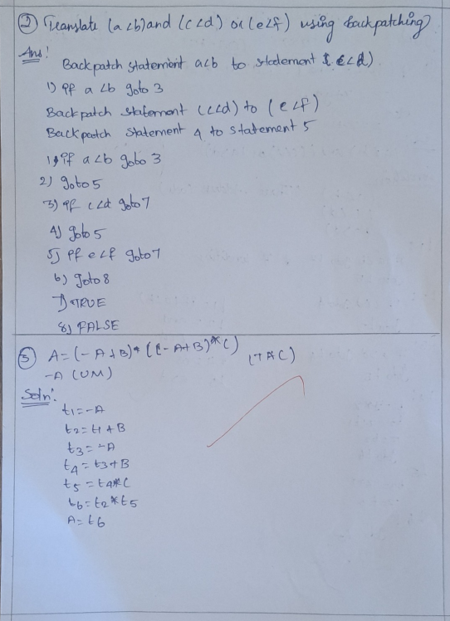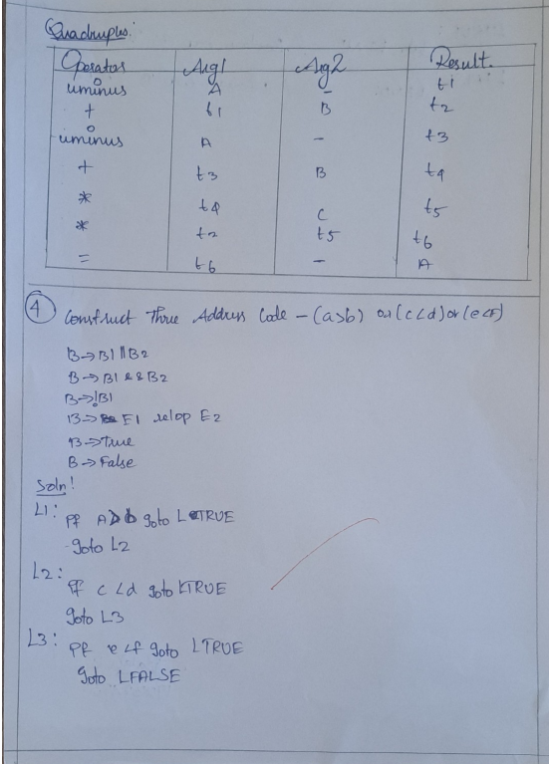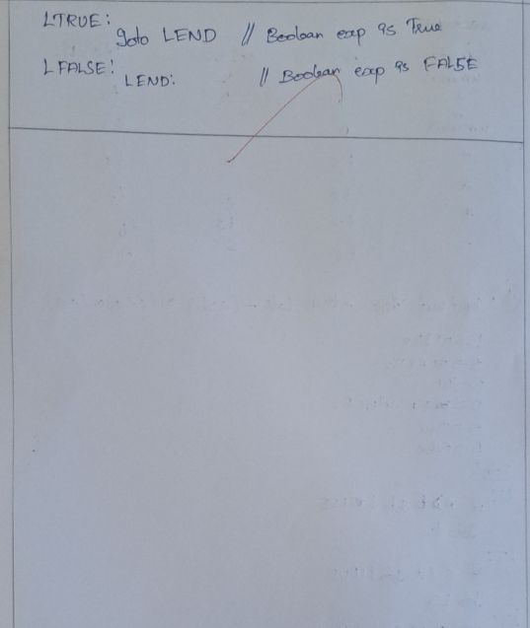

RUBRICS FOR CALCULATION
Criteria | Weightage | Level 4 –  Exemplary | Level 3 –  Proficient | Level 2 –  Developing | Level 1 –  Beginning
Understanding of Concepts | 25% | Demonstrates thorough,  accurate  understanding  of concepts | Good understanding  with minor gaps | Basic understanding with some  misconception  s | Poor understanding; major  misconceptions
Explanation | 25% | Detailed, wellexplained  answers with relevant examples | Clear explanation  with adequate details | Limited explanation; lacks depth | Poor or unclear explanation
Application | 20% | Effectively applies  concepts with strong  analytical ability | Applies concepts with minor errors | Limited application  with weak analysis | No application or incorrect analysis
Organization | 15% | Wellstructured  answers with  logical flow and coherence | Organized with minor issues in flow | Basic structure, lacks clarity | Poor organization,  incoherent answers
Accuracy | 15% | Completely accurate and covers all required points | Mostly accurate with minor omissions | Partially correct with missing points | Incorrect answers with major gaps

